RAJ — BAN240 Character Sheet
Manga Character Profile Dossier
BAN240 Toronto Metropolitan University | Original Manga Character | Academic Year 2025–2026
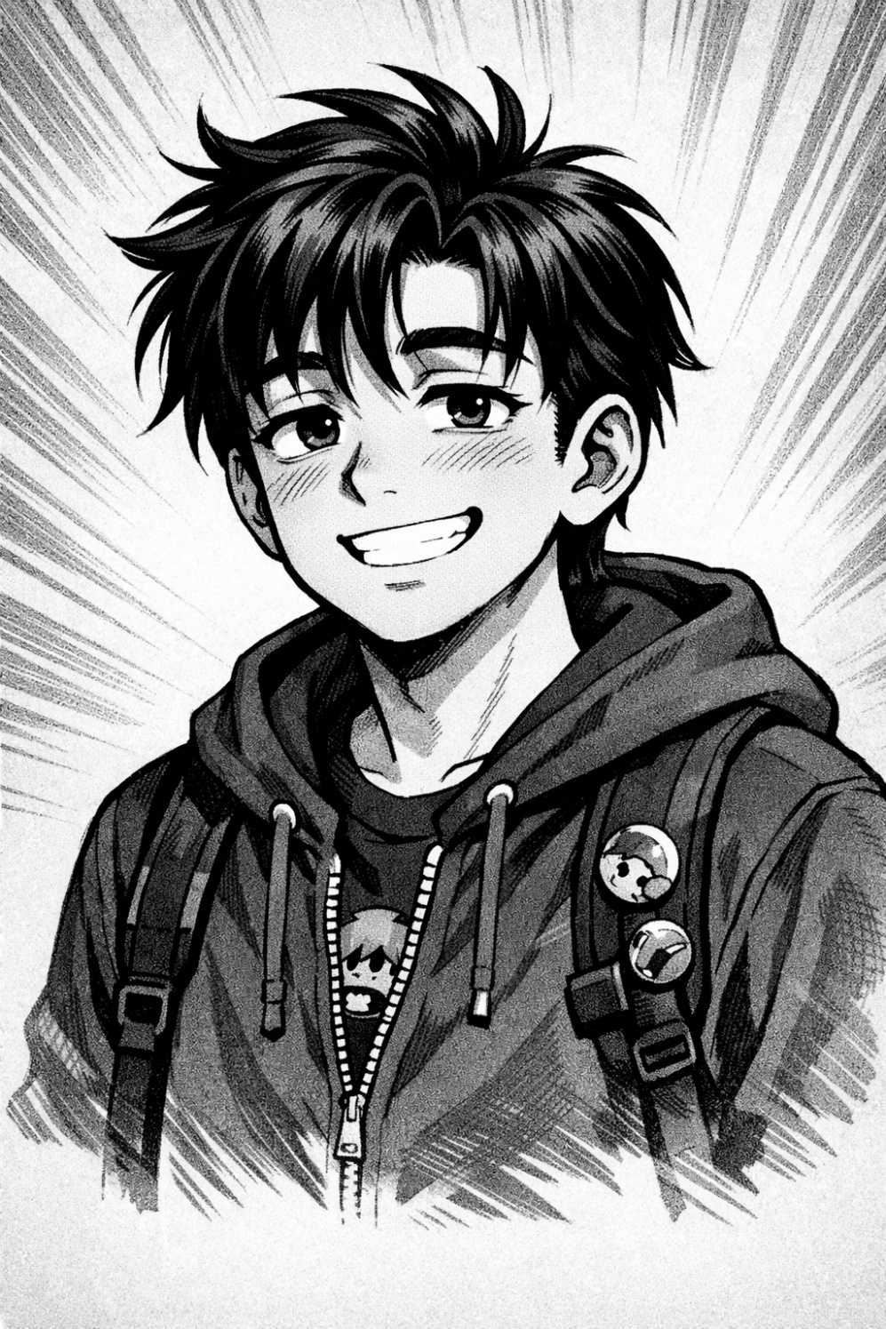

01 | Biographical Overview
At first glance, Raj is exactly what he appears to be: a second-year Business Technology Management student navigating the long commute, crowded lecture halls, and overloaded backpack of everyday university life. But like any well-drawn manga protagonist, what you see on the surface is only the first panel. Behind the half-lidded eyes and the perpetual coffee cup lies a fiercely loyal friend, a quietly competitive cricket obsessive, a late-night chef who "just follows the recipe," and a young man whose mundane daily grind — GO Train, TTC, campus, repeat — is, in its own way, a hero's journey. Raj is a fully realized character because he doesn't need a special power to be compelling. He just needs a delayed streetcar and a samosa.

02 | Demographics & Basic Info

Full Name | Raj Patel
Age | 20
Gender | Male
Ethnicity | South Asian (Indian-Canadian)
Hometown | Mississauga, Ontario, Canada
Current City | Toronto, Ontario, Canada
Occupation | Full-time Undergraduate Student
University | Toronto Metropolitan University (TMU)
Program | Business Technology Management
Year of Study | 2nd Year

03 | Physical Appearance & Manga-Style Portrait Description
Art direction brief — as if instructing a manga illustrator:
Height | 5'10"
Build | Lean, slightly lanky
Hair | Dark brown/black, slightly wavy, medium length — often a bit dishevelled from long commutes
Eyes | Dark brown, expressive; tends to carry a "half-lidded tired but still present" look — classic deadpan energy
Skin Tone | Warm medium-brown
Typical Outfit | Puffer jacket (navy or black), joggers or slim-fit jeans, white sneakers; one AirPod always in ear
Accessories | Worn-out student backpack overloaded with laptop, chargers, and snacks; transit card clipped to bag strap

Manga Art Style Notes
- Slightly exaggerated tired expressions — drooping eyes, slouched posture
- Sweat-drop mode triggers during high-stress moments (assignment deadlines, transit delays)
- Sparkle eyes activate when discussing cricket or a new anime season — sharp contrast to default expression
- Chibi mode triggered exclusively when he misses the GO Train — full tiny-body, dramatic tears

04 | Personality & Quirks

Core Disposition | Generally chill and easy-going, but quietly competitive — especially about cricket stats and fantasy leagues
Communication Style | Talks in half-sentences when tired (which is often); full sentences reserved for cricket arguments
Strong Opinions | Has deeply-held views on public transit: "The 504 streetcar has personally wronged me"
Stress Response | Stress-eats samosas from the food truck near TMU; denial follows
Energy Pattern | Gets inexplicably energized after 10 PM — his "second wind" hours run 10 PM to 2 AM
Loyalty | Extremely loyal friend; will show up for you, even if he complains the whole time
Hidden Talent | Secretly an excellent cook but denies all credit: "I just follow the recipe"
Guilty Habit | Mildly addicted to checking cricket scores mid-lecture; incognito tab does not fool anyone

05 | Hobbies & Interests
- Cricket — Passionate fan and casual player; follows IPL and international matches obsessively; runs a fantasy cricket team with friends and cousins. Cricket is not a hobby — it is a lifestyle.
- Anime & Manga — Primarily shonen genre; current favourites include Haikyuu!!, Slam Dunk, and Blue Lock; maintains a running watchlist of 40+ titles. New season announcements are treated as major life events.
- Gaming — Casual-to-moderate player; regularly plays FIFA, NBA 2K, and occasionally Valorant. Gaming sessions reliably begin at midnight, which explains a great deal.
- Cooking — Specializes in Indian comfort food: dal, butter chicken, biryani. Cooks for his roommates on weekends. Will not accept compliments gracefully.
- Music — Eclectic listener: Bollywood, Drake, AP Dhillon, and lo-fi hip hop during study sessions. Playlist shifts dramatically by time of day and stress level.
- Transit Observation — Unironically finds people-watching on the TTC and GO Transit deeply entertaining. Mentally narrates commuter backstories. Has considered writing them down.

06 | Sports Profile

Primary Sport (Fan) | Cricket — IPL devotee; favourite team: Mumbai Indians. Can and will cite match statistics unprompted.
Primary Sport (Participatory) | Recreational cricket on weekends in Mississauga with friends and cousins; competitive but plays it cool.
Secondary Sport (Fan) | Basketball — follows the Toronto Raptors casually; loyal by geography.
Anime Sports Influence | Haikyuu!! reignited his appreciation for volleyball strategy and team dynamics. Blue Lock created a temporary, intense interest in soccer that lasted approximately one season.

07 | Fandom Profile

Cricket / IPL | Deep lore knowledge; can cite match stats from memory without prompting. IPL season disrupts his entire schedule.
Haikyuu!! | Favourite manga and anime; owns two volumes; quotes it in daily conversation — entirely unironically.
Blue Lock | Recent hyperfixation; actively debates player rankings and tactics with friends. Opinions are strong and frequent.
Slam Dunk | Respects it as a foundational classic; was introduced to it by his dad. A meaningful shared text.
Toronto Raptors | Casual but loyal fan; owns a Scottie Barnes jersey. Shows up for playoffs without fail.
Mumbai Indians | Core identity-level fandom. IPL season brings chaotic, often sleep-depriving energy to Raj's life.
AP Dhillon / Bollywood | Music fandom with real-world engagement; attends concerts when possible. Bollywood occupies a significant portion of his playlists.
Drake | Toronto loyalty is non-negotiable. No further explanation offered or required.

08 | Commute & Daily Life

[ PANEL DESCRIPTION — DAILY ROUTINE ]
The alarm goes off in Mississauga. Raj silences it twice. On the third try, he gets up — puffer jacket already draped over the chair, backpack already packed from the night before like a soldier who has made peace with his fate. He has thirty minutes before the MiWay bus.

Home Base | Mississauga (parents' house)
Commute Route | MiWay bus → GO Train (Lakeshore West line) → TTC streetcar → walk to TMU campus
Commute Duration | Approximately 1.5 hours each way — 3 hours of transit daily
Commute Mood | Resigned acceptance; uses the time to watch anime episodes, listen to music, or stare blankly into the middle distance
Signature Move | Falls asleep on the GO Train exactly one stop before Square One — wakes up in a cold sweat, panicked
Transit Pet Peeve | 504 King streetcar delays. "It's always the 504." Always.
On-Campus Arrival | Arrives with a Starbucks coffee from the Yonge location; finds a corner seat; opens three browser tabs simultaneously — lecture slides, Reddit, cricket scores
Lunch | Hits the food truck strip near campus; samosas are non-negotiable regardless of queue length
After Class | Either heads to the library (reluctantly) or straight home immediately — no in-between state exists

[ PANEL — THE 504 ]
"Next 504 King: 23 minutes." The app updates. "Next 504 King: 31 minutes." Raj stares at the screen. The sweat-drop forms. He considers walking. He does not walk. He waits, and he narrates the story of the commuter next to him in his head.

09 | Character Role & Narrative Function

Raj serves as the grounded, relatable everyman protagonist — the character readers root for not because he is exceptional, but because he is genuinely trying. His commute is his daily trial; his friend group is his found family; his late-night gaming sessions are his decompression ritual. The mundane rhythms of his life — the delayed streetcar, the overloaded backpack, the samosa queue — form the fabric of a story that feels lived-in and real.
In a school manga setting, Raj is the character who stumbles into the plot entirely by accident — wrong place, wrong time, too tired to argue — and ends up being the emotional anchor of the group. He is not the loudest voice or the most dramatic presence, but when things get hard, people turn to him. He shows up. He always does. Even if he complains about the 504 the entire time.

Narrative Role Summary: Everyman protagonist — relatable, loyal, quietly resilient. Best deployed as the emotional core of an ensemble cast in a contemporary school-life or slice-of-life manga setting.

BAN240 — Manga Character Profile Dossier | Character: Raj Patel | Toronto Metropolitan University | Generated: June 2026
Original character created for academic purposes. All details are fictional and for course use only.

